**Problem 1: Micro-micro-organism RNA expression**

You have been assigned to take a csv file of 6 samples and 8 genes from an extremely simple organism that runs on 8 genes and create a plot of the data comparing expressions between the two sample groups (contained within ‘sample.csv’). Luckily, you’ve found a function online that lets you plot easily given that you provide the correct inputs.

Given:

* A csv file of the data: ‘sample.csv’ with sample groups A and B, each with 3 replicates
* A .py function that takes in inputs of values (an n-by-m array of means where n is the number of sample groups and m is the number of proteins of interests), proteins (a one-dimensional list of the proteins of interest as strings), labels (a one-dimensional list of the sample groups), title (what the figure will be named), and std (an n-by-m array of standard deviations, same size as ‘values’)

Task:

* Create a script that:
  + Imports sample.csv as a pandas dataframe
  + Creates a NumPy array of size 2 rows by 8 columns, where row 1 is the average expression of each gene for Group A and row 2 is the average expression of each gene for Group B
  + Creates a NumPy array of size 8 rows by 2 columns, where row 1 is the standard deviation of each gene for Group A and row 2 is the standard deviation of each gene for Group B
  + Calls the given function ‘expPlotter’ and provides necessary inputs to plot the graph
  + Calculates the difference of average gene expression of each gene between Group B and Group A and for each gene, prints a statement to the console that says, “(gene name) is upregulated/downregulated” depending on whether Group B is upregulated/downregulated compared to A (hint: combine for loop and if statement here)
* Additionally, function expPlotter() is missing a few features that you would like to add to the graph:
  + Change the legend font size to 8
  + Change figure dpi to 300
  + Set y-label as “Raw RNA Measure” and x-label as “Genes”
  + Save plot as a .tif to the current directory as “(title of graph)-fig.tif”
  + Change rotation of x-axis labels to 45 degrees

This is what your output should look like:

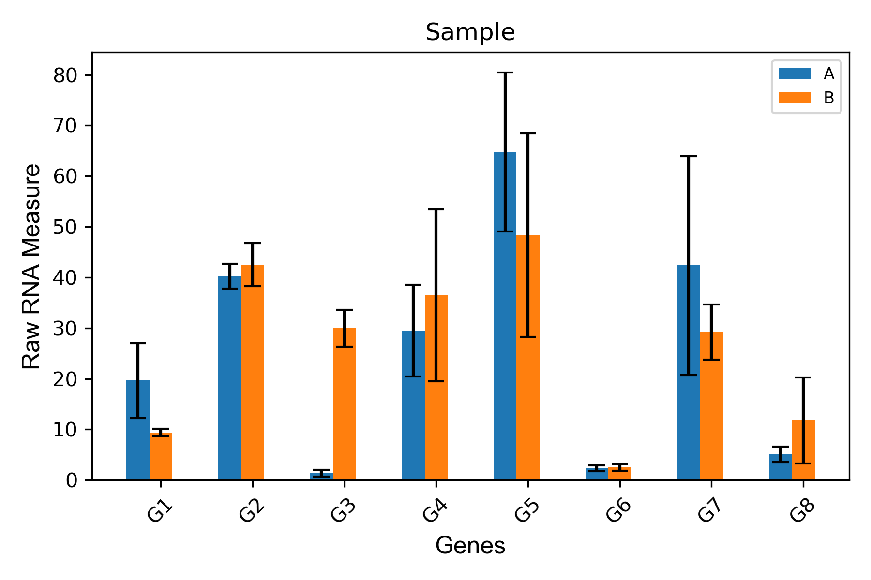

(Saved as “Sample-fig.tif” to current directory)

The console should show:

G1 is downregulated

G2 is upregulated

G3 is upregulated

G4 is upregulated

G5 is downregulated

G6 is upregulated

G7 is downregulated

G8 is upregulated